Question 1 ER diagram.

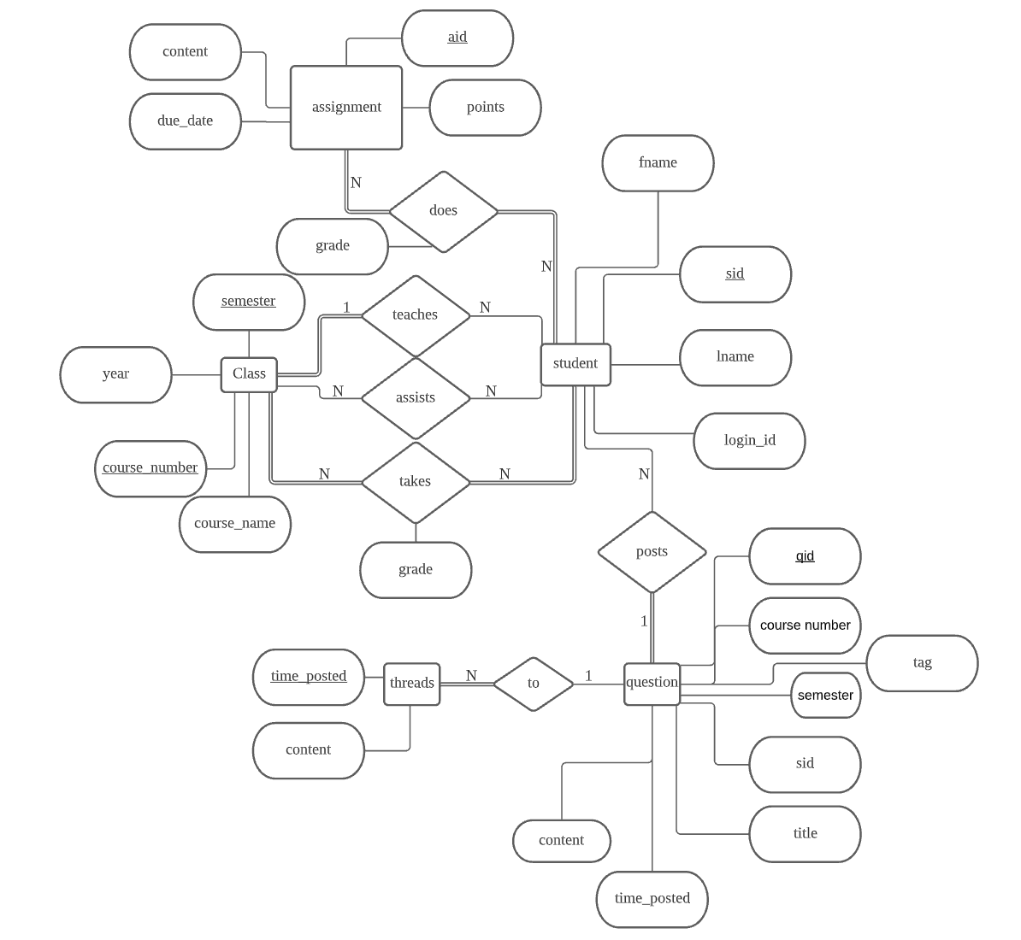

#Assume each student also has a distinct login_id.

#Assume the course name never changes- for example, CS 377 will always refer to the class Database Systems.

#Assume each student can only post once in one second.

#Assume a student can take the same class in multiple semesters.

#Assume the class numbers are all 5-digit character strings (i.e. Math classes are numbered MA***)

#Assume all time-related features are in timestamp format

Question 2

student: sid, login_id, lname, fname

class: course_number, semester, year

Teaches: course number, semester, sid, year

Assists: course number, semester, sid, year

takes: sid, course_number, semester, year, grade

question: qid, course_number, semester, year, sid, title, content, time_posted

tags: qid, tag, course_number, semester, year

thread: qid, sid, time_posted, content

assignment: aid, course_number, semester, year, name, content, due_date, point

does: sid, aid, grade

course_title: course_number, course_name

Question 3

Functional dependencies:

class:

course_number -> course_name

student:

login_id -> lname, fname

assignment:

course_number, semester, year, name -> point, due_date

Database Normalization:

1. Since each attribute has atomic values, 1NF is achieved.
2. Database in 1NF. The first functional dependency violates one of the requirements for 2NF- part of the key functionally determines a nonkey attribute. Instead, we can remove the attribute course_name from the relation class, and create a new relation with course_number and course_name.
3. Now let’s look at the rest of the FDs. The second FD does not violate requirements for 3NF since login_id is a superkey of the student relation, assuming each student has a unique login_id. The third FD does not violate 3NF for the same reason. Thus, the database is in 3NF.

Question 6-part c

**Data base description**

Relation name: class

|  |  |  |
| --- | --- | --- |
| Attribute name | Attribute type | Attribute description |
| course_number | CHAR(5) | Number of a course as a combination of letters and numbers. (i.e. CS377) |
| semester | VARCHAR(8) | The semester in which the course was offered. First letter capitalized. |
| year | INT | Four-digit number representing the year in which the course was offered. |

Relation name: student

|  |  |  |
| --- | --- | --- |
| Attribute name | Attribute type | Attribute description |
| login_id | VARCHAR(10) | Each student’s login id. Should not be visible to other personnel for security purpose. |
| fname | VARCHAR(10) | Student’s first name. |
| lname | VARCHAR(10) | Student’s last name. |
| sid | CHAR(10) | 10-digit student id. Unique identifier each student. |

Relation name: teaches

|  |  |  |
| --- | --- | --- |
| Attribute name | Attribute type | Attribute description |
| course_number | CHAR(5) | Number of a course as a combination of letters and numbers. (i.e. CS377) |
| semester | VARCHAR(8) | The semester in which the course was offered. First letter capitalized. |
| year | INT | Four-digit number representing the year in which the course was offered. |
| sid | CHAR(10) | Student id of the instructor of a course. |

Relation name: assists

|  |  |  |
| --- | --- | --- |
| Attribute name | Attribute type | Attribute description |
| course_number | CHAR(5) | Number of a course as a combination of letters and numbers. (i.e. CS377) |
| semester | VARCHAR(8) | The semester in which the course was offered. First letter capitalized. |
| year | INT | Four-digit number representing the year in which the course was offered. |
| sid | CHAR(10) | Student id of the TA of a course. |

Relation name: takes

|  |  |  |
| --- | --- | --- |
| Attribute name | Attribute type | Attribute description |
| sid | CHAR(10) | Student id of a student of a course. |
| course_number | CHAR(5) | Number of a course as a combination of letters and numbers. (i.e. CS377) |
| semester | VARCHAR(8) | The semester in which the course was offered. First letter capitalized. |
| grade | VARCHAR(12) | A student’s letter grade. Shows ‘In progress’ for ongoing classes. |
| year | INT | Four-digit number representing the year in which the course was offered. |

Relation name: question

|  |  |  |
| --- | --- | --- |
| Attribute name | Attribute type | Attribute description |
| course_number | CHAR(5) | Number of a course as a combination of letters and numbers. (i.e. CS377) |
| semester | VARCHAR(8) | The semester in which the course was offered. First letter capitalized. |
| year | INT | Four-digit number representing the year in which the course was offered. |
| title | VARCHAR(50) | Title of a question posted by user. |
| time_posted | TIMESTAMP | Timestamp values recording the time that a question was posted.  In format YYYY-MM-DD HH:MM:SS. |
| content | VARCHAR(300) | Content of a question post. |
| sid | CHAR(10) | Student id of a student of a course. |
| qid | INT | Unique identifier of each question. |

Relation name: tags

|  |  |  |
| --- | --- | --- |
| Attribute name | Attribute type | Attribute description |
| course_number | CHAR(5) | Number of a course as a combination of letters and numbers. (i.e. CS377) |
| semester | VARCHAR(8) | The semester in which the course was offered. First letter capitalized. |
| year | INT | Four-digit number representing the year in which the course was offered. |
| tag | VARCHAR(20) | Category that each question falls under. available tags for each class are predetermined. |
| qid | INT | Unique identifier of each question. |

Relation name: threads

|  |  |  |
| --- | --- | --- |
| Attribute name | Attribute type | Attribute description |
| qid | INT | Unique identifier of each question. |
| time_posted | TIMESTAMP | Timestamp values recording the time that a reply was posted.  In format YYYY-MM-DD HH:MM:SS. |
| content | VARCHAR(300) | Content of a reply post. |
| sid | CHAR(10) | Student id of a student of a course. |

Relation name: assignment

|  |  |  |
| --- | --- | --- |
| Attribute name | Attribute type | Attribute description |
| course_number | CHAR(5) | Number of a course as a combination of letters and numbers. (i.e. CS377) |
| semester | VARCHAR(8) | The semester in which the course was offered. First letter capitalized. |
| year | INT | Four-digit number representing the year in which the course was offered. |
| name | VARCHAR(30) | Name of an assignment. Published by instructors or Tas. |
| due_date | TIMESTAMP | The time an assignment is due. In format YYYY-MM-DD HH:MM:SS. |
| content | VARCHAR(300) | Content of a question post. |
| point | INT | Total point on an assignment. |
| aid | INT | Unique identifier for assignments. |

Relation name: does

|  |  |  |
| --- | --- | --- |
| Attribute name | Attribute type | Attribute description |
| sid | CHAR(10) | Student id of a student of a course. |
| grade | INT | The number of point a student get on an assignment. |
| aid | INT | Unique identifier for assignments. |

Relation name: course_title

|  |  |  |
| --- | --- | --- |
| Attribute name | Attribute type | Attribute description |
| course_name | VARCHAR(25) | Name of a class. |
| course_number | CHAR(5) | Number of a course as a combination of letters and numbers. (i.e. CS377) |

How to navigate around the system:

The default page of my system is the login page, where a user provides their student id and login id. After clicking on the login button, they are redirected to a verification page where the system tests if the input pair is valid. If not, they get redicted to the login page to try again. Otherwise, they have the choice to continue on to their student course page, where they can view the courses they are taking, type in a course of which they want to view the detail, or they can continue as an instructor, which redirects them to their instructor over view page. If they decide to view the course details, they are presented with the details of all their assignments for that class, and the choice to continue on to Q&A page for that class. In the Q&A page, they can view all the posts, filter by tags, post questions and/or replies.

If they continue on to instructor page, they can view the courses they are teaching or assisting. After choosing a specific course to focus on, they can view all students in the class and their respective letter grade. They have the choice to add an assignment, to check a student’s assignment and change grade, or to change the letter grade of a student.